Google map "Distance Matrix API" to be enabled on your Google Maps API key, in addition to the "Maps JavaScript API" and "Places API".

INPUT:
Project location:Street, City, State, Zip code, Coordinates
(e.g. 170 W 96th St, New York, NY 10025)

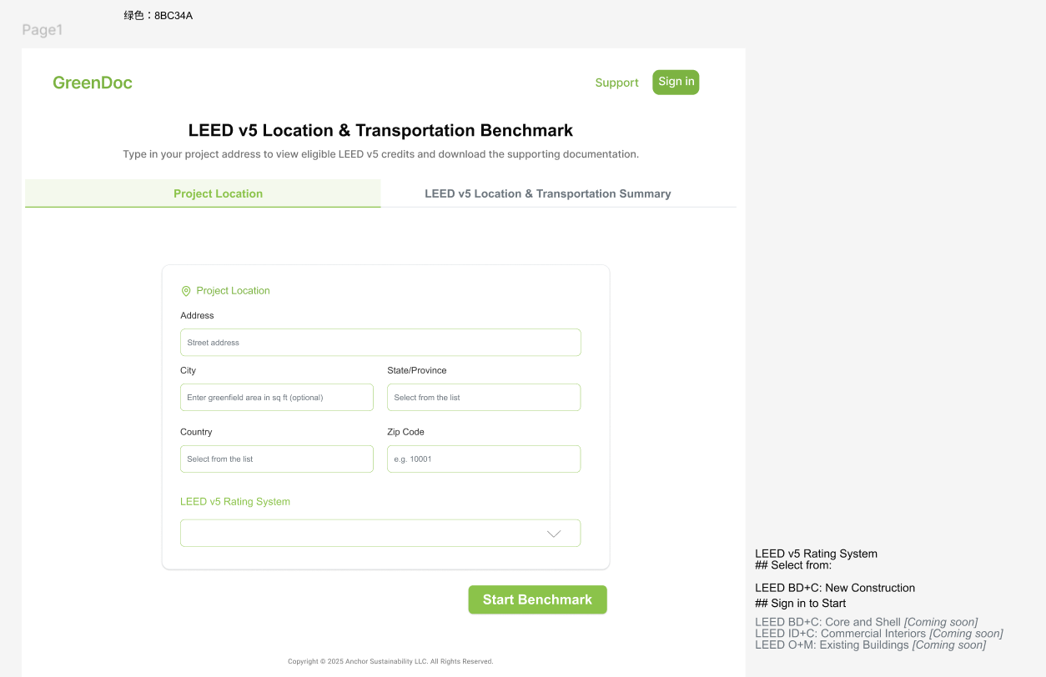
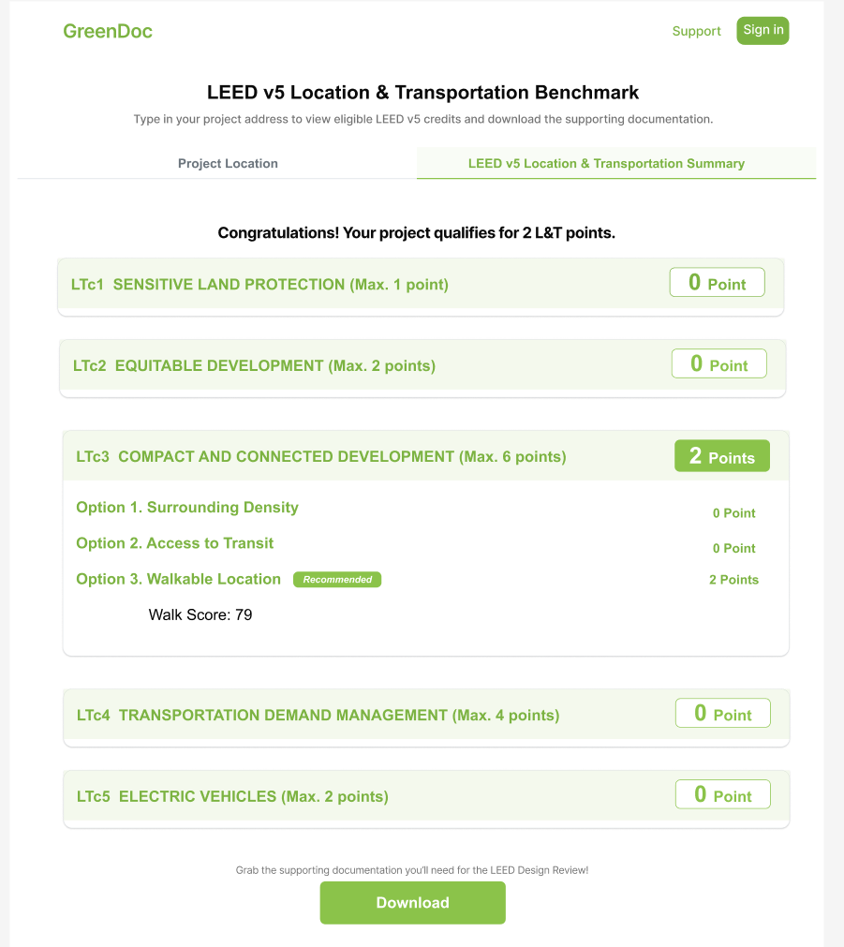

LT c3 Compact And Connected Development (6 pts)

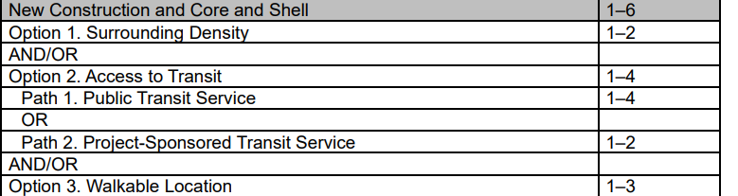

Option 1. Surrounding Density (1–2 points)

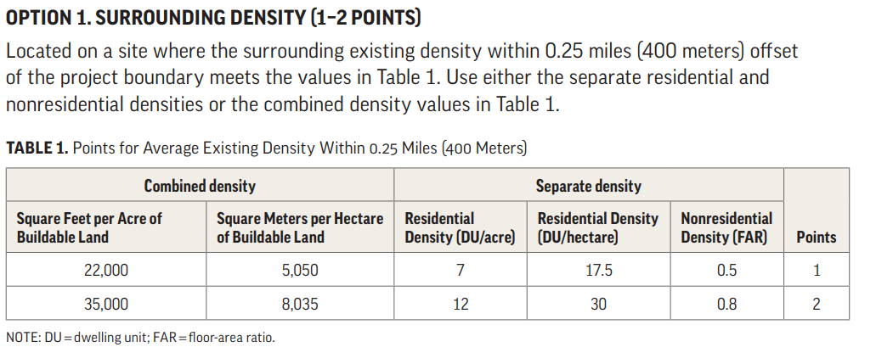

Option 2. Access to Transit (1–4 points)
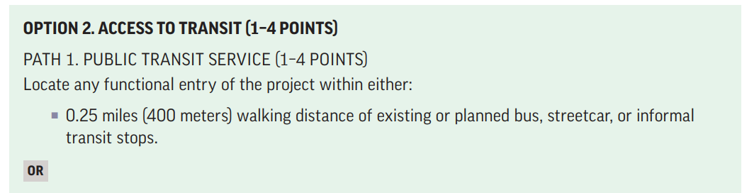
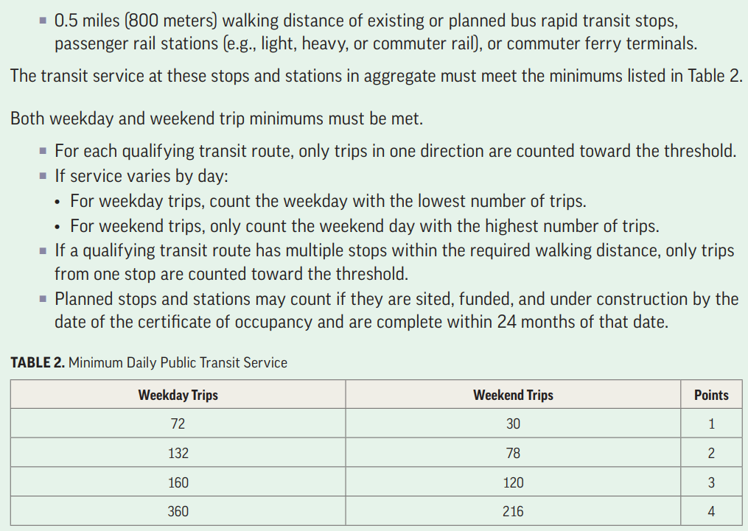
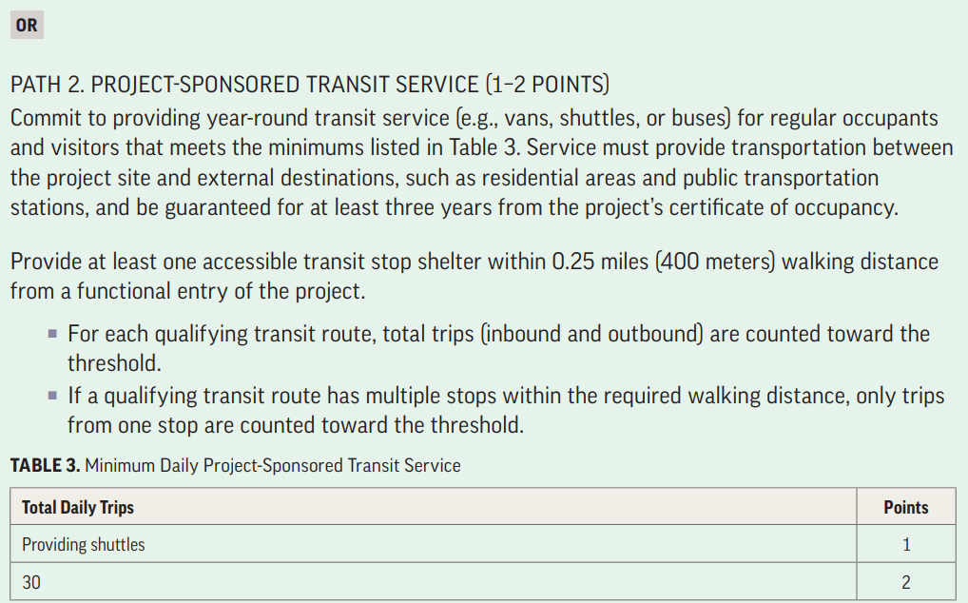

Step 1: Open https://www.google.com/maps

Step 2: Search project location
E.g. 845 Columbus Ave, New York, NY 10025

Step 3: Turn on traffic layer
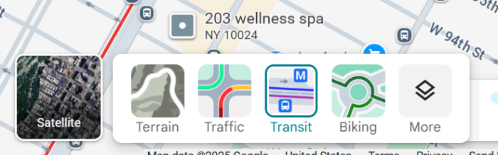

Step 4: Confirm bus stops within 0.25 miles (400 meters) walking distance
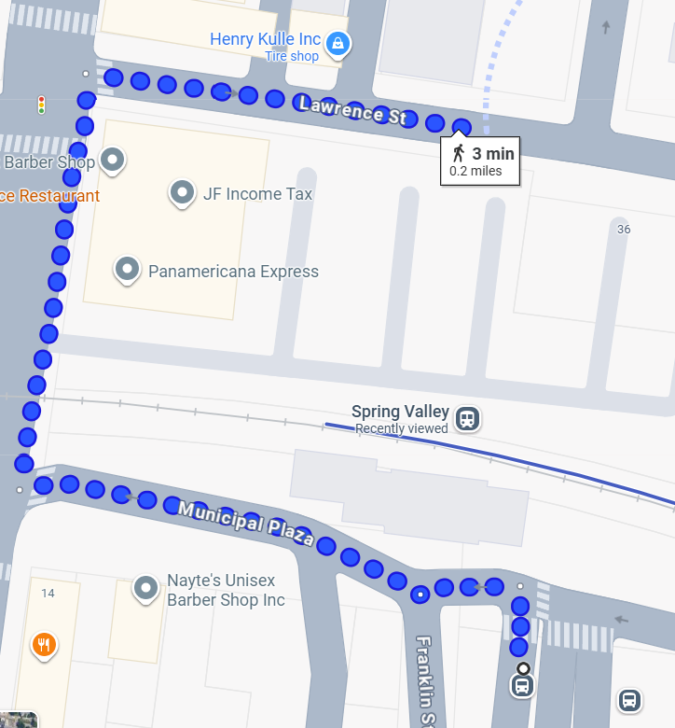

Step 5: Get bus info from qualified location
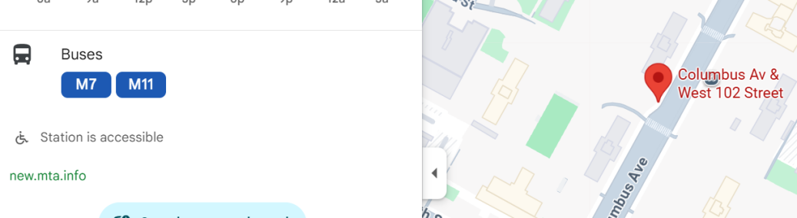

Step 6: Get bus schedule https://www.mta.info/schedules/bus/manhattan, count total weekday & weekend trips (one direction). Print bus schedule as PDF.
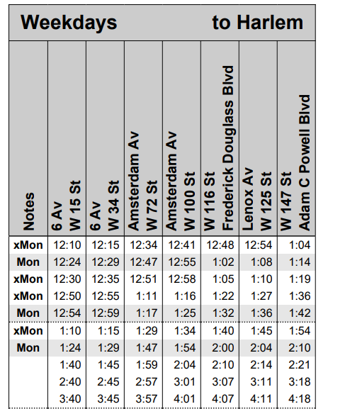

Exclude special trips (xMon, Mon).

Step 7: Add trips from qualified bus stations & bus lines together.

Weekday trips | Weekend trips | LT c3 Points
72 | 30 | 1
132 | 78 | 2
160 | 120 | 3
360 | 216 | 4

Output 1:

LEED Qualified Transit Service Table

Route Name | Weekend trips | LT c3 Points
72 | 30 | 1
132 | 78 | 2
160 | 120 | 3
360 | 216 | 4
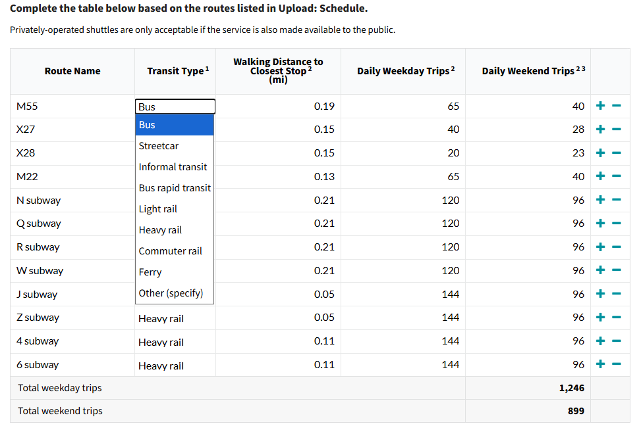

Output 2:
PDF transit schedules/timetable
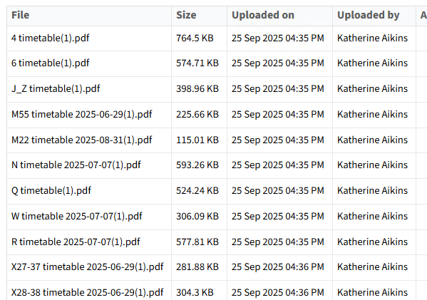

bus rapid transit
An enhanced bus system that operates on exclusive bus lanes or other transit rights-of-way. The system is designed to combine the flexibility of buses with the efficiency of rail.

light rail transit service using two- or three-car trains in a right-of-way that is often separated from other traffic modes. Spacing between stations tends to be ½ mileor more, and maximum operating speeds are typically 40–55 mph (65–90 kmh). Light-rail corridors typically extend 10 or more miles (16 kilometers).

Option 3. Walkable Location (1–3 points)
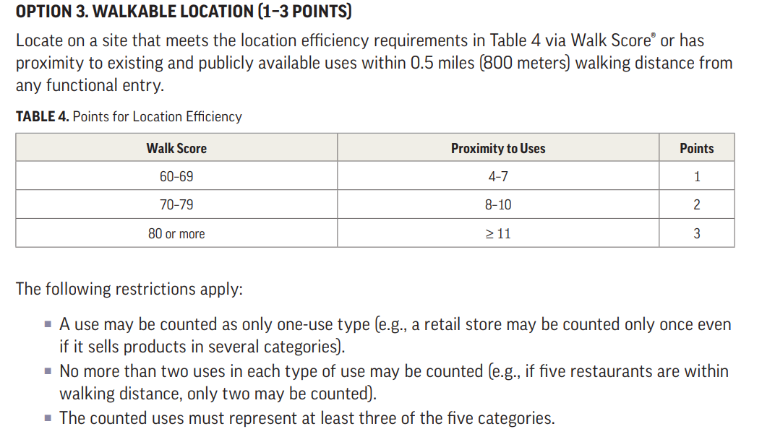
Step 0: Extract zip code from project location. (e.g. 10025)
Step 1: Open https://www.walkscore.com/
Step 2: Enter zip code, click the search button

Step 3: Get Walkscore, Print the page as PDF
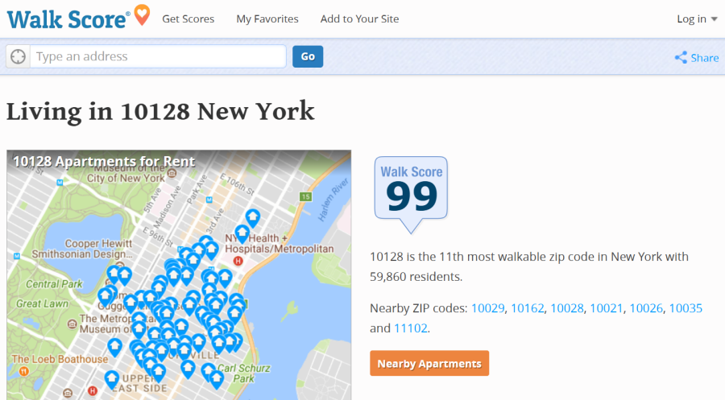

Step 4: Calculate LT c3 points based on walkscore

Walk Score | LT c3 Points
<60 | 0
60-69 | 1
70-79 | 2
>=80 | 3

